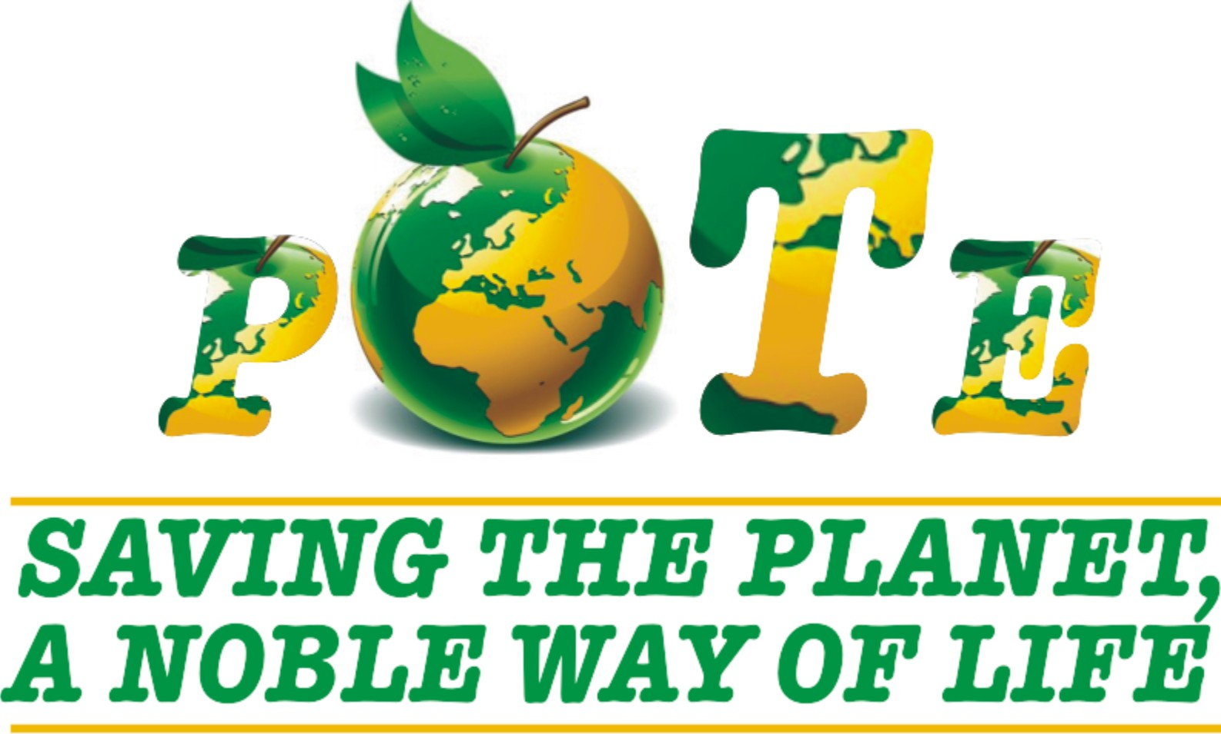

PALS OF THE EARTH (POTE) ORGANISATION PROFILE


Research and Advocacy on:
Climate Change, Environmental Conservation, Sustainable Agriculture Practice, Sustainable Forest and Resource Management, Sustainable Livelihood Management



LETTER OF INTRODUCTION

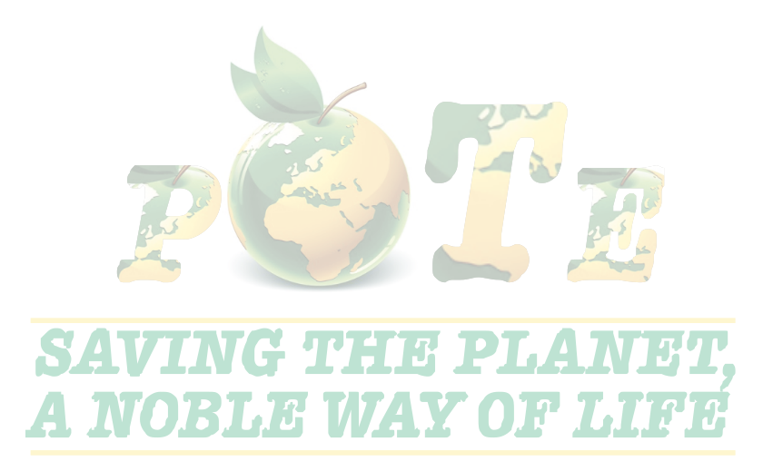The above mentioned organization ‘Pals of the Earth’ abbreviated as (POTE) wish to introduce itself to your outfit as a non governmental organization whose ultimate aim is to work and create awareness about our environment and certain anthropogenic activities which pose threats to human survival and creates ecological imbalance on the planet leading to climate change and natural disasters. The issue of climate change and natural disasters is no longer a dilemma of mental hallucinations but a problem of global reality.

In view of this, Pals of the Earth is born to form a lasting collaboration and mutual co-operation with your highly esteemed organization in the fight against global warming by Reducing Emission from Deforestation and Degradation (REDD) and the pollution of our environment as well as the preservation of wetlands and natural habitats within the territorial region of Ghana and Africa at Large.

“POTE” also engages in educating local farmers on the alternate way of farming and the benefits of diverting to sustainable green methods of farming (Organic Farming) in order to produce chemical free products.
Research and Advocacy on:
Climate Change, Environmental Conservation, Sustainable Agriculture Practice, Sustainable Forest and Resource Management, Sustainable Livelihood Management

Climate Change and natural disasters as we all know now is a problem due to ecological imbalance of which we are the cause, so we all should be part of the solution.

And the only sure way of saving our planet is for us to live in harmony with the natural world and this needs extensive education and awareness creation nationwide as well as projects tailored towards environmental preservation.

With sincere understanding, trust and collaborative efforts, we believe this mutual co-operation will achieve its desired goals in helping to preserve our environment and conserve its species.

Please see attached detailed breakdown of our History, activities and mode of operations in the subsequent pages.

We look forward for a reliable and strong co-operation, to help save our planet.
May providence replenish every fragment of goodness we put in this vision.

Thank you.
Mensah, Frederick
Founder / Executive Director

PALS OF THE EARTH (POTE) HISTORY INBRIEF
Pals of the Earth with it records dating as far back as in the mid 80s was known as Nemco Farm an organization which sole interest was into nursing seedlings and tree plantation for environmental preservation and as well creating socio-economic and community co-benefit where these projects were initiated.

With no adequate funding the activities of the organization came to a halt in the late 90s to early 2000 with most of its plantations being encroached by the natives. The only property left standing is its seedling nursing facilities and a tree forest area covering approximately 360 hectares, located in the Central Region of Ghana.

Now, Nemco farm is PALS OF THE EARTH registered under the Department of Registrar General on the 8th of April 2010 as a non-profit organization with a more expanded tentacles, activities and projects

PALS OF THE EARTH (POTE) is a Ghanaian NGO with its projects mainly based in the Western Region of Ghana. Its head office operates from Greater Accra, the national capital of Ghana making it conveniently accessible to stakeholders, donors and partners. Plans are far advanced to extend its activities to Brong Ahafo, Eastern and Central Regions of Ghana in due time.

Pals of the Earth seek to promote fundamental socio-economic development that enhances self-sufficiency and self-reliance for advancement of people within a sustainable framework of development. Pals of the Earth has been in existence and formally attained a legal status to operate as a non-governmental organization by the Registrar Generals Department Ghana in 2010 with registration number G’32,028, Social Welfare registration number DSW/5298 and Accra Metropolitan Assembly registration number A 206/10/928. From 2010 to date Pals of the Earth has been implementing environmental projects.

Between 2010 and 2015 the staffs of the organization were fully involved in the implementation of environmental projects undertaken by the international NGO's by carrying out animation and training/capacity building activities.
Our activities now do not only cover nursing seedlings and tree plantation but extend to awareness creation and general issues regarding environmental protection, Sustainable Farming Practices and the cause, effect and post effects of climate change/ global warming etc.

Most of our advocacy programme is done through the circulation of educative environmental publications such as stickers, brochures and posters.

Seminars and workshops are the major means employed by the Pals of the Earth to disseminate all relevant information regarding the preservation of our environment, its co-inhabitants, green Lifestyle, sustainable Farming, forest and resource management, cause, treats and preventive measures of handling climate change/ global warming. In the light of such activities, POTE hopes to be very effective and dedicated to its course to achieve its objective.

Our Mission
Pals of the Earth (POTE) has the mission of educating people from all walks of lives on the persisting problem of climate change and the urgent need for environmental preservation in Ghana. And the necessary measures needed to be implemented as urgently as possible to help safeguard our environment.

Our Vision
Pals of the Earth (POTE) has the ultimate vision of becoming one of the most vibrant organizations in the country, that will champion the course of education and projects geared towards environmental preservation, promotion of plant-based diet and the safe existence of all living things on the planet.

Core Values:
- Integrity
- Respect
- Accountability
- Collaboration
- Innovation

OBJECTIVES

The objectives of POTE are as follows:
- The organization of periodic workshops and conferences to educate public on the need for:
- Environmental preservation
- Conservation of natural species
- The preservation of available wetlands
- Sustainable/renewable energy usage
- Sustainable Agricultural practices
- Enhance human and community development;
- Enhance environmental conservation and management for sustainable livelihoods;
- Promote understanding between governance and the governed, men and women and their roles and functions.

FIELDS OF ENGAGEMENTS
- Women and youth empowerment on environment and gender equity.
- Organize workshops, press conferences and public lectures on the causes, effects and post effects of climate change / global warming.
- To embark on projects such as tree planting to reduce carbon emissions.
- Engages local and community farmers in training programmes to educate them on the benefits of Sustainable Agricultural Practices.
- Pote engages in locals in capacity building on the benefits of Sustainable Forest Management and alternate sources of livelihood
- Engages in research into new and sustainable ways of living and the use of environmental friendly materials. (Green Technology)

Areas of Strategic Focus
POTE main strategic focal areas are:
- Forestry, Environmental conservation and management
- Water, Sanitation and health/hygiene promotion
- Governance

Mainstreamed areas include: Gender, Youth development, Training and Research, and HIV/AIDS

Target: Women, Youth, Children and the vulnerable & marginalized.

Funding: Pals of the Earth activities have so far been funded by: Rufford Foundation, Government of Ghana, The European Commission, District Assemblies, and Municipal.

Organizational Structure: Pals of the Earth has a 9 member Board of Directors, a management team of 4 making the core staff comprising the Executive Director, National Programme Coordinator, Project Coordinators, Administrator and Accounts Officer. There are other full-time staffs who are the field staff, part time staffs and volunteers.

Memberships to coalitions and networks: Pals of the Earth is a member of some international and local groups, networks, coalitions etc. These include; Western Region Network of Development NGO’s (WERENGO) Forest Watch Ghana (FWG); Local Government Network (LOGNet), Ghana Ghana National Education Coalition Campaign (GNECC); Coalition of Civil Society Organizations in Land (CICOL); and West Africa Network for Peace Building (WANEP) Ghana.

MODE OF OPERATIONS
Pals of the Earth will use every little resource within our reach to propagate and educate people across board as much as possible to help curb, and if possible avert the unforeseen dangers of the climate and global warming confronting humankind and aid in reducing emissions from deforestation and degradation (REDD) of the environment. Under listed is our mode of operations:

AWARENESS CREATION
Seminars and Workshops
Pals of the Earth organizes periodic seminars and workshops in collaboration with other local and international organizations of like minds to educate people and to create awareness about their choices and its rippling effects on their lives and the environment, the effects of pollution on our environment, and what we can do as a people in our own domestic / industrial ways to reduce green house gas emission (GHGs), environmental degradation and pollution to help save our wonderful planet. Through our workshop of capacity building, the locals in the communities are equipped with the benefits of sustainable forest management/alternate livelihood.

NURSING SEEDLINGS & TREE PLANTING PROJECTS
Pals of the Earth has dynamic and dedicated people / organisations who have specialized in nursing seedlings for tree plantation to help assimilated the carbon emitted into the atmosphere due to human activities and industrialization.

Publication
Pals of the Earth has develop a well equipped, informed and dynamic publication team who has been putting together and collating relevant and educative information through research into publication materials such as brochures, flyers, handbills and newsletters as a means of educating the public in realizing this urgent and noble course. Publications are distributed to the general public free of charge.

Disaster Aid and Rescue Team
Pals of the earth has a competent and dedicated voluntary rescue team who are ever ready to attend to the needs and aid disaster victims during periods of natural disasters.

PALS OF THE EARTH PHYSICAL ASSET

The organization has a fully furnish rented office at Sahara Dansoman where it currently operates.

Pals of the earth (POTE) also have the under listed equipments to their credit:

- A Hyundai Elantra Salon Car
- List of Office Equipments:
- Photocopier Machine IR 1600
- Canon Fax Machine
- Two Desktop computers
- One Laptop Computer
- One LaserJet 1000 black and White Printers
- One LaserJet 4L black and White Printers
- One DeskJet 940c Colour Printers
- One Commercial Binding Machine
- One Lamination Machine
- Two Split Air conditioners
- Vodafone Telephone Line
- Fully Network Internet Connection
- Set of Office Furniture

- In addition, there is an ongoing two (2) storey building office complex project at foundation level, located at Mallam main road, Gravel junction Gbawei. The entire first floor will serve as permanent office space for the organization

PALS OF THE EARTH STAFF INFORMATION

Pals of the Earth has a 9 member Board of Directors, a management team of 4 making the core staff comprising the Executive Director, National Programme Coordinator, Project Coordinators, Administrator and Accounts Officer. There are other full-time staffs who are the field staff, part time staffs and volunteers.

- Volunteer Staff
These are people from all walks of life who believe in our ideals and objectives and voluntarily dedicate their service to Pals of the earth in support of our vision. These noble people are not paid any form of salary but are given provisional allowance to take care what we term “on the project expenses” such as transportation, feeding and hotels bills when necessary.
Pals of the earth have a total number of ten (15) volunteers and counting who have pledged their service, commitment and dedication to our organization.

PROFILE OF SOME KEY STAFF OF THE ORGANIZATION RESPONSIBLE FOR THE IMPLEMENTATION OF PROJECTS

Frederick Mensah is the Executive Director and a Development Consultant for over 10 years, responsible for the overall supervision of the Organization. He is responsive for the effective implementation of all projects. He is responsible for coordinating, planning and monitoring the implementation of the project. He is responsible for providing back up services to all projects.

Jerry Affum Offei is the National Programmes Coordinator and has more than 14 years experience in development management. His role as the National Programme Coordinator includes supervising all field activities but supporting in the preparation of financial statements, compiles technical report, relate to major stakeholders such as Donors, state institutions, representing the Organization in major engagements and meetings. Coordinating and monitoring of activities of the organization. Also he collate all report from fields into a comprehensive report and report to executive director and donors

Alfred Gyimah is the Finance Officer responsible for the payment funds to implementation clients, reconcile the books and accounts on monthly bases, payment of SSNIT and income Tax, payment of expenses, receipts of cheques and other administrative work, preparation of account, payment of monthly salaries keeping of record, preparation of financial reporting.

Raphael Anue Mensah is the Project Coordinator and Research specialist responsible for research into Sustainable Agricultural Practices in achieving food security. He also assists in monitoring programs and activities; coordinating of report and attending meetings on behave of the organizational platforms. He also embarks on other fields of researches which are of interest to the organization with the help of our volunteers.

OFFICE LOCATION
Our office is currently located Opposite the Ecobank Branch, Dansoman, Sahara, Accra-Ghana. West Africa. House Number 12

POSTAL ADDRESS
Post Office Box MP 312, Mamprobi, Accra. Ghana, West-Africa

CONTACT NUMBERS
Office Line: 00233 – 302 – 30 87 73 / 00233 54 093 5470

24 hr HOTLINE
00233 – 24 – 37 32 86 1 / 00233 27 1732 704

EMAIL
poteinfo@gmail.com

WEBSITE
http://palsoftheearth.yolasite.com

